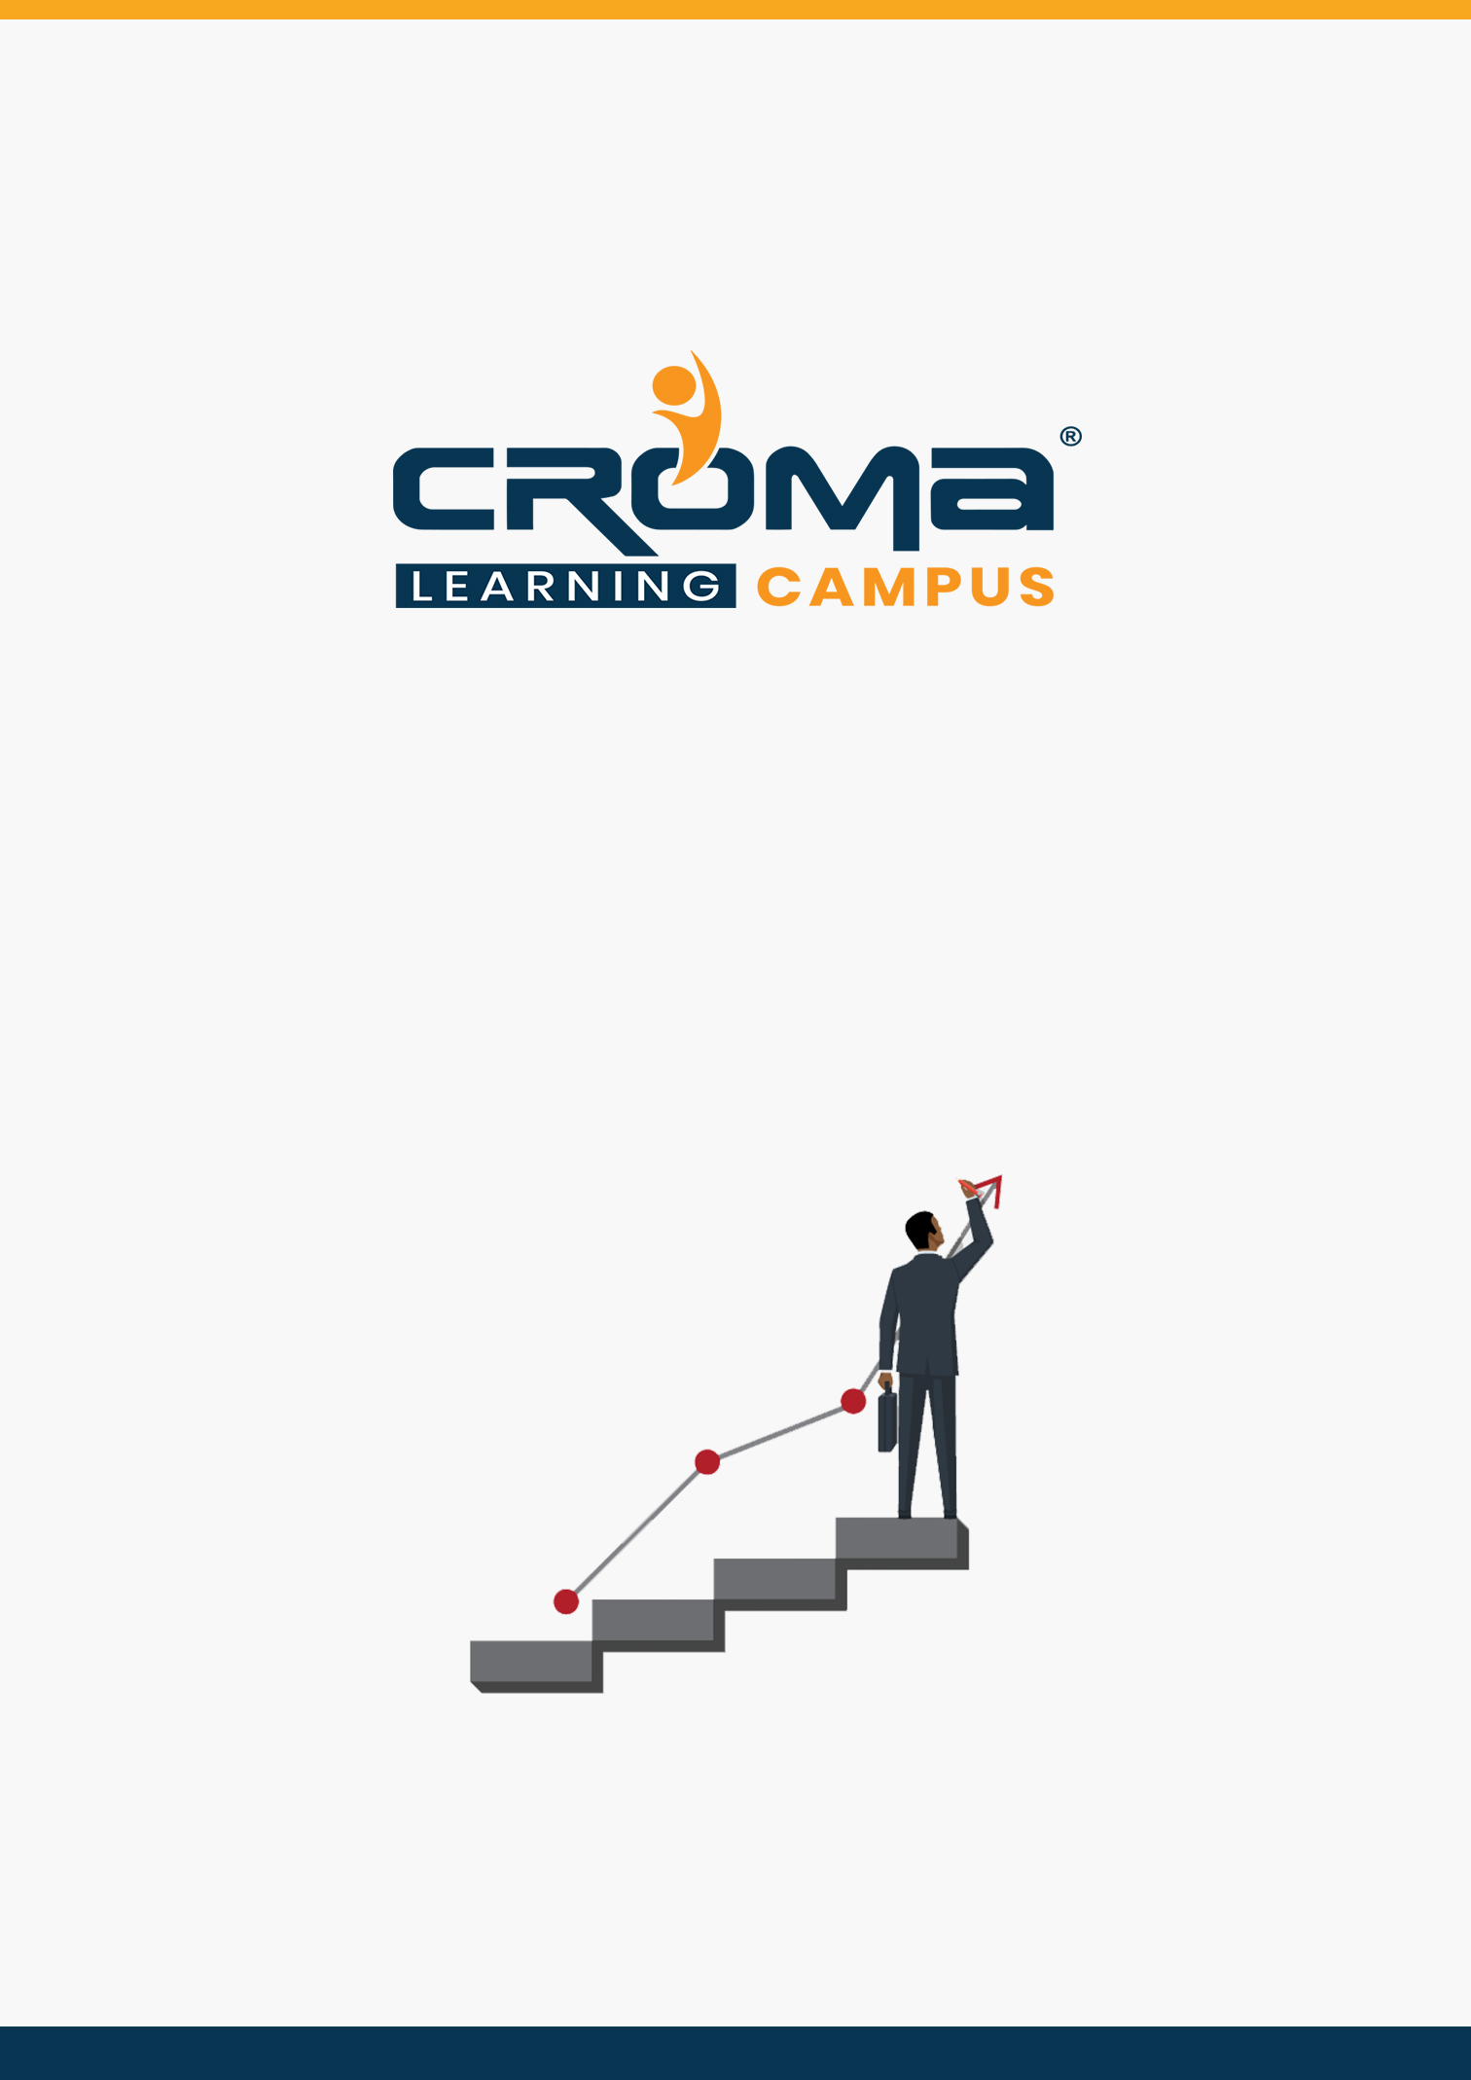

**AZ 900 Microsoft Azure Fundamentals Training Curriculum**

**STRUCTURE**

**www.cromacampus.com | helpdesk@cromacampus.com | +91-120-4155255**

**AZ 900 Microsoft Azure Fundamentals Training**

*Gain fundamental skills in Azure and give a quick start to your career like never before.*

**Course Objectives:**

* Prepare yourself for the certification exam and clear your certification exam in the first attempt
* Add an attractive credential in your resume that is really appreciated by Companies.
* Improve your overall Cloud management skills, azure development skills, and explore more job prospects with better salary packages.
* Boost your social media profiles especially LinkedIn by adding this certification and become one of the top persons to be chosen by industries.

**AZ 900 Certification Training Description:**

With our AZ-900 “Microsoft Azure fundamentals” certification Training you will learn foundational knowledge of cloud services and how those services are provided with Microsoft Azure. The exam is intended for candidates who are just beginning to work with cloud-based solutions and services or are new to Azure.

Azure Fundamentals exam is an opportunity to prove knowledge of cloud concepts, Azure services, Azure workloads, security and privacy in Azure, as well as Azure pricing and support. Candidates should be familiar with the general technology concepts, including concepts of networking, storage, compute, application support, and application development.

Azure Fundamentals can be used to prepare for other Azure role-based or specialty certifications, but it is not a prerequisite for any of them.

***Here are some strong reasons why should you consider this certification course.***

* Validate your Azure Fundamental skills like storage, networking, compute, security, and other Cloud operations on Microsoft Azure.
* Validate your basic skills and learn how Azure can help you in designing robust cloud solutions
* Top-paying info-tech certification in the world.
* It provides you with global recognition for your knowledge, skills, and experience.
* The organization looks for those who know Oracle Cloud, AWS, Azure, etc.

**Necessary Details about Certification You Must Know**

* Certification Name – AZ-900 Microsoft Azure Fundamentals Training
* Prerequisites: None
* Exam Duration: 150 minutes
* Number of Questions: 40-60
* Passing score: 700 (Out of 1000)
* Exam Cost: USD 165.00
* Validity: 2 years

**Certification Exam Structure:**

* Describe cloud concepts (15-20%)
* Describe core Azure services (30-35%)
* Describe security, privacy, compliance, and trust (25-30%)
* Describe Azure Pricing Service Level Agreements, and Lifecycles (20-25%)

**Course Content:**

**Module 1: Introduction**

* Introduction
  + Cloud Computing Basics
  + Why Cloud computing?
  + What is Microsoft Azure?’
  + Cloud terminologies
  + High Availability, Scalability, Elasticity, Agility
  + Fault Tolerance and Disaster Recovery
  + Describe the principles of economies of scale
  + Capital Expenditure vs. Operational Expenditure
  + Describe the consumption-based model
* Cloud Services
  + Describe Infrastructure-as-a-Service (IaaS),
  + Describe Platform-as-a-Service (PaaS)
  + Describe Software-as-a-Service (SaaS)
  + Compare and contrast the three different service types
* Cloud Models
  + Describe Public cloud
  + Describe Private cloud
  + Describe Hybrid cloud
  + Compare and contrast the three different cloud models

**Module 2: Azure Architecture and Management Tools**

* Core Azure architectural components
  + Describe Azure Architecture
  + Describe Regions
  + Describe Availability Zones
  + Describe Resource Groups
  + Describe Azure Resource Manager
  + Benefits & Usage of core Azure architectural components
* Management Tools
  + Azure Portal
  + Azure PowerShell
  + Azure CLI
  + Cloud Shell
  + Azure Advisor

**Module 3: Core Products in Azure**

* Products available for Compute
  + Virtual Machines
  + Virtual Machine Scale Sets
  + App Services
  + Azure Container Instances (ACI)
  + Azure Kubernetes Service (AKS)
* Products available for Networking
  + Virtual Network
  + Load Balancer
  + VPN Gateway
  + Application Gateway
  + Content Delivery Network
* Products available for Storage
  + Blob Storage,
  + Disk Storage,
  + File Storage,
  + Archive Storage
* Products available for Databases
  + Cosmos DB
  + Azure SQL Database,
  + Azure Database for MySQL
  + Azure Database for PostgreSQL
  + Azure Database Migration service
  + Azure Marketplace and its usage scenarios

**Module 4: Solutions in Azure**

* Describe Internet of Things (IoT)
* Products available for IoT on Azure
* IoT Hub and IoT Central
* Big Data and Analytics
* Products available for Big Data & Analytics
* Azure Synapse Analytics
* HDInsight
* Azure Databricks
* Artificial Intelligence (AI)
* Products available for AI
* Azure Machine Learning Service and Studio
* Serverless computing
* Azure products available for serverless computing
* Azure Functions, Logic Apps and Event Grid
* DevOps solutions available on Azure
* Azure DevOps and Azure DevTest Labs
* Benefits and outcomes of using Azure solutions

**Module 5: Security, Privacy, Compliance, and Trust**

* Describe securing network connectivity in Azure
  + Describe Network Security Groups (NSG)
  + Describe Application Security Groups (ASG)
  + Describe User Defined Rules (UDR)
  + Describe Azure Firewall
  + Describe Azure DDoS Protection
  + Choose an appropriate Azure security solution
* Describe core Azure Identity services
  + Describe the difference between authentication and authorization
  + Describe Azure Active Directory
  + Describe Azure Multi-Factor Authentication
* Describe security tools and features of Azure
  + Describe Azure Security Center
  + Describe Azure Security Center usage scenarios
  + Describe Key Vault
  + Describe Azure Information Protection (AIP)
  + Describe Azure Advanced Threat Protection (ATP)
* Describe Azure governance methodologies
  + Describe policies and initiatives with Azure Policy
  + Describe Role-Based Access Control (RBAC)
  + Describe Locks
  + Describe Azure Advisor security assistance
  + Describe Azure Blueprints
* Describe monitoring and reporting options in Azure
  + Describe Azure Monitor
  + Describe Azure Service Health
  + Describe the use cases and benefits of Azure Monitor and Azure Service Health
* Describe privacy, compliance and data protection standards in Azure
  + Describe industry compliance terms such as GDPR, ISO and NIST
  + Describe the Microsoft Privacy Statement
  + Describe the Trust center
  + Describe the Service Trust Portal
  + Describe Compliance Manager
  + Determine if Azure is compliant for a business need
  + Describe Azure Government cloud services
  + Describe Azure China cloud services

**Module 6: Azure Pricing and Management costs**

* Describe Azure subscriptions
  + Describe an Azure Subscription
  + Uses and options with Azure subscriptions
  + Access control and offer types
  + Describe subscription management using Management groups
* Describe planning and management of costs
* Describe options for purchasing Azure products and services
* Describe options around Azure Free account
* Describe the factors affecting costs such as resource types, services, locations, ingress and egress traffic
* Describe Zones for billing purposes
* Describe the Pricing calculator
* Describe the Total Cost of Ownership (TCO) calculator
* Describe best practices for minimizing Azure costs such as performing cost analysis, creating spending limits and quotas, using tags to identify cost owners, using Azure
* reservations and using Azure Advisor recommendations
* Describe Azure Cost Management

**Module 7: Service Level Agreements and Lifecycles**

* Describe Azure Service Level Agreements (SLAs)
  + Describe a Service Level Agreement (SLA)
  + Describe Composite SLAs
  + Describe how to determine an appropriate SLA for an application
* Describe service lifecycle in Azure
  + Describe Public and Private Preview features
  + Describe the term General Availability (GA)
  + Describe how to monitor feature updates and product changes

**Module 8: Placement Guide**

* Tips to clear an Interview
* Common Interview questions and answers
* AZ 900 Interview Questions and Answers
* Resume Building Guide
* Attempt for AZ 900 Global Certification Exam
* Start applying for Jobs